Visual Identity Recognition Techniques
A Review of Modern Feature Learning for Visual Identity Recognition

Mohammad Erfan Messbah
university of technology
Tehran, Iran
Messbah.m.e@gmail.com

Abstract—This paper presents a comprehensive review of the state of the art in deep learning-based visual identity recognition, focusing on the distinct yet related tasks of Human Re-identification (ReID) and Building Geolocalization. We systematically analyze the foundational components of this field, including key benchmark datasets such as Market-1501 and University-1652, and the critical evaluation metrics like mAP and Rank-k accuracy. We then survey the progression of methodologies, from the establishment of strong baselines with the "Bag of Tricks" to advanced architectural designs like OSNet and specialized attention mechanisms (FSRA) that address scale and temporal variations. The review further explores how models are adapting to complex challenges by leveraging self-supervised geometric features for structured objects and incorporating powerful Vision-Language Models (VLMs) like CLIP for enhanced semantic understanding. Our analysis concludes by identifying the most pressing open challenges: achieving robust domain generalization, ensuring privacy preservation in person-centric systems, and developing computationally efficient solutions for large-scale, real-world deployment.
Keywords:
Re-identification (ReID), Geolocalization, Attention Mechanism, Domain Generalization, Vision-Language Models (VLMs)

Introduction
The confluence of machine learning and deep learning has ushered in a transformative era for computer vision, enabling unprecedented capabilities in object recognition, tracking, and spatial awareness. Central to the advancement of intelligent surveillance, autonomous navigation, and public safety are two closely related yet distinct challenges: Re-identification (ReID) and Geolocalization/Building ID. Both tasks are fundamentally about establishing identity—whether of an entity or a location—across different perspectives, times, and sensory inputs.
Re-identification (ReID) is the challenge of recognizing a specific object or individual (the instance) across a network of non-overlapping cameras or over time. It is a critical component for persistent tracking and forensic search in large-scale visual systems. The core difficulty lies in learning a robust, view-invariant feature representation that can distinguish between many different identities despite significant appearance changes due to variations in viewpoint, pose, illumination, and occlusion.

Geolocalization and Building ID focus on establishing the spatial context, either by identifying a specific location or structure from a query image (place recognition) or by precisely estimating the camera's pose within a mapped environment (visual localization). This is essential for robotics, augmented reality, and large-scale mapping applications.
While traditionally studied in isolation, a comprehensive review demands a unified perspective to highlight shared architectural principles, common challenges, and potential cross-pollination of techniques. We propose to structure this review around the nature of the entity being identified, creating a clear and systematic classification of the research landscape:

Human ID (Person Re-identification): The foundational and most mature area, focusing on tracking a specific person across disjoint camera views. Key challenges include clothes changing, partial occlusion, and intra-class similarity (people wearing similar outfits).

Machine ID (Object and Vehicle Re-identification): Extends the ReID paradigm to inanimate or non-human objects, such as vehicles, drones, robots, or specific equipment. This category often deals with less deformable objects but introduces challenges like a massive inventory of visually similar models (e.g., car models) and license plate-independent matching.

Building ID and Geolocalization (Place Recognition/Visual Localization): Shifts the focus from a mobile instance to a static, fixed entity or its spatial coordinates. This involves matching a query image to a database of geo-tagged images or a 3D map to determine where the image was captured, facing difficulties related to seasonal change, weather, and extreme viewpoint variation.
This paper aims to provide an expert-level review of the cutting-edge deep learning methodologies employed across all three categories, dissecting the advancements in feature representation, metric learning, and large-scale retrieval to chart the current state, major research gaps, and future directions for truly intelligent and context-aware visual systems.
while pure visual Vehicle Re-identification faces severe practical limitations due to high inter-model similarity and is often surpassed in real-world applications by robust multi-modal systems incorporating License Plate Recognition (LPR), the academic category of Machine ID remains vital. We will address this by framing Vehicle ReID as a key benchmark for fine-grained instance recognition, where the challenge is to extract subtle discriminative features beyond gross appearance (like dents or aftermarket accessories). Crucially, the "Machine ID" classification also encompasses general Object ReID (e.g., specific robots or equipment), ensuring a comprehensive review that acknowledges the practical obsolescence of general visual-only car ReID while retaining the necessary academic scope.
This comprehensive review meticulously explores the intricate details of the methodologies underpinning ReID and geolocalization across all three categories. We will systematically dissect the advancements in deep learning architectures from feature representation networks to sophisticated metric learning and attention mechanisms. Furthermore, the paper provides a critical analysis of the standardized datasets used for benchmarking, discusses the nuances of evaluation protocols (including Rank-k accuracy, mAP, and localization error metrics), and examines how these components collectively define the state-of-the-art and future trajectory of instance and place recognition in computer vision.

Datasets
The foundation of robust ReID and geolocalization research rests upon diverse and challenging datasets that simulate real-world surveillance and localization difficulties. We categorize these essential benchmarks based on the target entity: Human ID and Building ID/Geolocalization.

Human ID Datasets
For Person Re-identification (ReID), the Market-1501 dataset [1] is the seminal and most widely adopted benchmark. Captured by six overlapping camera views on a university campus, it provides data for 1,501 distinct individuals. Its large scale and realistic surveillance environment, featuring significant variations in pose, illumination, and background clutter, have made it the standard for evaluating ReID model performance, specifically using Rank-1 accuracy and Mean Average Precision (mAP). Complementing this, datasets like the IUST Person ReID dataset address the increasing need for models robust to greater complexity, often focusing on challenges inherent in dense public spaces, such as heavy occlusion and scenarios with high visual similarity among individuals, pushing the boundaries of feature discriminability in congested environments.

Building ID and Geolocalization Datasets
In the domain of Building ID and Geolocalization, datasets are designed to handle extreme viewpoint changes and static identity. University-1652[2] is a crucial benchmark for cross-view image geolocalization, linking images of 1,652 buildings across numerous cities. The core challenge of this dataset is the retrieval task between ground-view (street-level) query images and a gallery of aerial or satellite images, forcing models to learn features invariant to massive changes in perspective and scale. Conversely, the SUES-200 [3] benchmark focuses specifically on Building Re-identification (Building ReID) at a more granular level. It provides images for 200 distinct building instances captured –under various environmental conditions, including changes in weather and lighting. This dataset is instrumental for developing fine-grained structural feature extractors capable of reliably identifying a specific architectural landmark from a large, diverse gallery of static structures.

method
The pursuit of robust and discriminative feature representation is central to advancing ReID and geolocalization performance. This section details the key methodological innovations that have driven the field forward, moving beyond general-purpose deep convolutional neural networks. We trace the evolution from establishing robust training practices—exemplified by strong baselines—to the introduction of specialized architectures designed to combat specific challenges like viewpoint variation, occlusion, and high instance similarity. The discussion is organized around three main technical directions: fundamental feature learning and optimization (Bag of Tricks, OSNet), the integration of sophisticated attention and geometric mechanisms (Deep Attention Aware, FSRA, VehicleNet), and the recent paradigm shift toward utilizing pre-trained, generalized knowledge from Vision-Language Models (CLIP-ReID) for semantic understanding and improved generalization.

Bag of Tricks and A Strong Baseline for Deep Person Re-identification
The paper "Bag of Tricks and Strong Baselines for Deep Person Re-identification" (Luo et al., 2019) [4] represents a pivotal moment in ReID research by demonstrating that many performance gains previously attributed to complex, novel network architectures could be achieved by simply employing a "Bag of Tricks"—a collection of robust, yet often overlooked, training methodologies and optimization components.
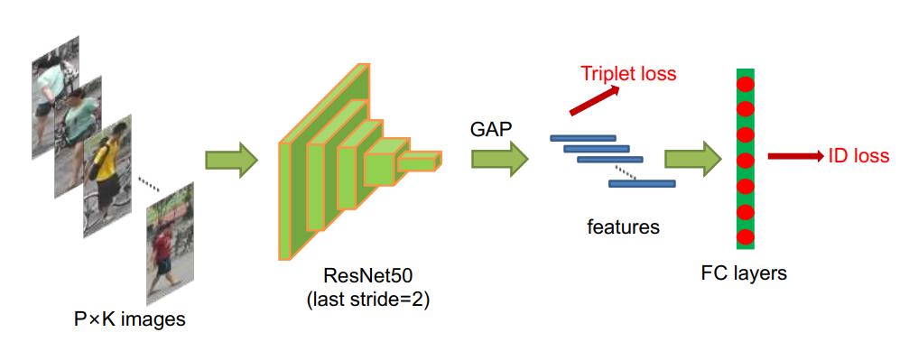
Figure 1) bag of Trick(baseline) architecture
This work shifted the focus of the community by establishing dramatically stronger baselines, often surpassing the performance of specialized state-of-the-art models using only simple CNN backbones like ResNet-50. Key components of this "Bag of Tricks" include optimized data processing (e.g., Random Erasing data augmentation for robustness against occlusion), refined training strategies (e.g., warm-up learning rate schedules and specific layer-wise pooling), and the effective fusion of standard loss functions, particularly combining Identity Loss (treating ReID as a multi-class classification problem) with Triplet Loss (using metric learning to enforce intra-class compactness and inter-class separation). By validating the collective impact of these techniques, the paper provided a standardized, highly competitive foundation for future ReID work, ensuring that subsequent architectural innovations were measured against a truly challenging benchmark.

Deep Attention Aware Feature Learning for Person Re-Identification
Following the establishment of strong feature learning baselines, research shifted toward improving robustness against common real-world challenges like occlusion, cluttered backgrounds, and pose variation. The paper "Deep Attention Aware Feature Learning for Person Re-Identification" (Li et al., 2020) [4] addresses this by integrating deep attention mechanisms to focus the model's feature extraction on the most discriminative parts of the person, while suppressing irrelevant noise.
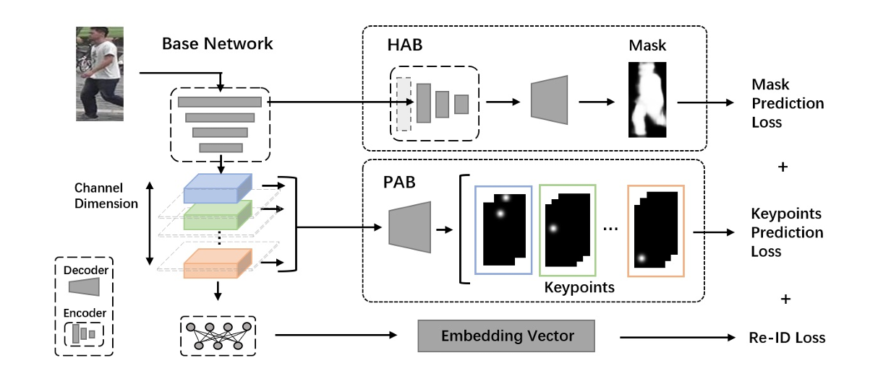
Figure 2) Deep Attention Aware Feature Learning for Person Re-Identification architecture
The core idea is that not all spatial or channel features are equally important for identity matching. By introducing attention modules, the network learns to dynamically assign higher weights to features corresponding to key identity cues (e.g., specific clothing patterns or carried objects) and lower weights to features from the background or occluded regions. This creates a fine-grained feature representation that is less susceptible to environmental interference. This mechanism represents a major conceptual advance, allowing ReID models to move beyond simple global feature extraction to part-aware and context-sensitive matching, which is crucial for achieving state-of-the-art performance in highly challenging datasets.

VehicleNet: Learning Robust Visual Representation for Vehicle Re-identification
"VehicleNet: Learning Robust Visual Representation for Vehicle Re-identification" (He et al., 2020) [5] provides a significant methodology tailored to the challenging Machine ID category, specifically addressing the high inter-class similarity of vehicles. Acknowledging the constraints of pure visual Vehicle ReID (as previously discussed), this work aims to push the boundaries of what is possible without relying on license plate recognition.
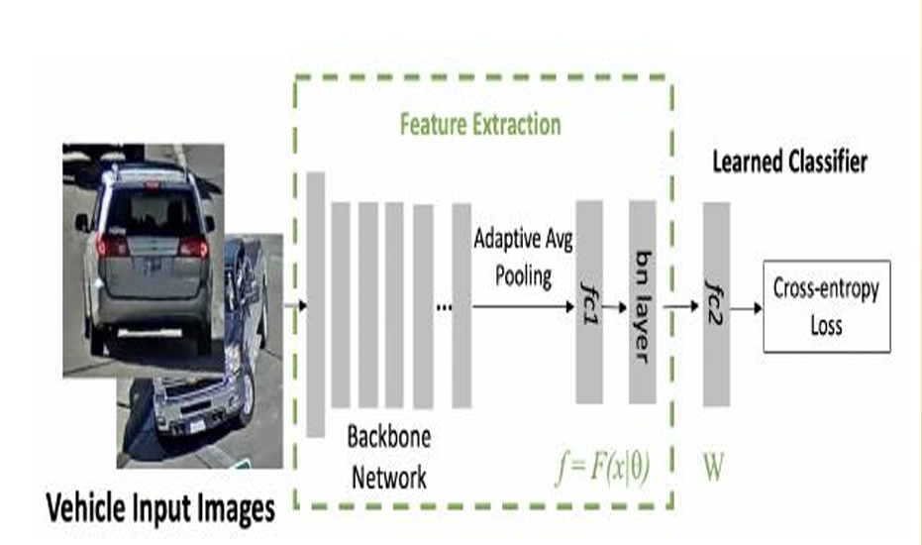
Figure 3) VehicleNet: Learning Robust Visual Representation for Vehicle Re-identification architecture
The core contribution is the design of the VehicleNet architecture, which focuses on learning highly robust and view-invariant feature embeddings. The model addresses the extreme viewpoint variations common in traffic surveillance by integrating specialized components (often part-based modules or attention mechanisms) that force the network to attend to subtle, yet discriminative, regions like car accessories, specific lighting features, or fine-grained texture details that define a specific vehicle instance. By combining optimized deep feature representation with refined metric learning strategies, VehicleNet established a new state-of-the-art for visual-only vehicle retrieval, highlighting the deep learning efforts to overcome the severe limitations posed by highly structured, non-deformable objects captured under varying surveillance angles.

Self-Supervised Geometric Feature Discovery via Interpretable Attention for Vehicle Re-Identification
Addressing the instability of appearance features in Vehicle ReID under drastic viewpoint changes, the paper "Self-Supervised Geometric Feature Discovery via Interpretable Attention" (Li et al., ICCV 2021) [6] introduced a sophisticated method to locate and leverage geometric part features without manual annotation. The core innovation is a Self-Supervised Geometric Features Discovery (GFD) module combined with an Interpretable Attention mechanism. Instead of relying solely on general features, the model learns to automatically identify geometrically stable and highly discriminative vehicle parts (such as wheels, windows, and headlights).
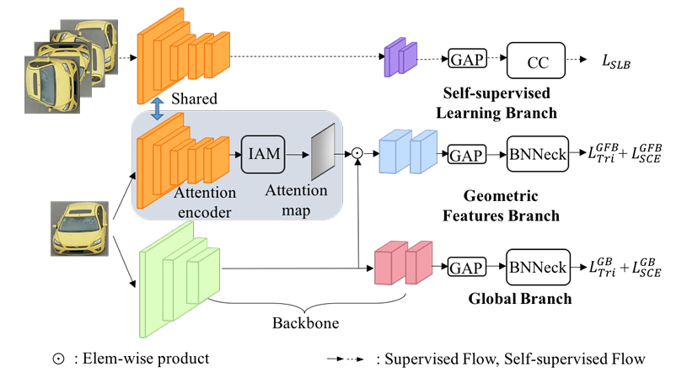
Figure 4) Self-Supervised Geometric Feature Discovery via Interpretable Attention for Vehicle Re-Identification architecture
The attention mechanism is designed to be interpretable, meaning its output maps are explicitly encouraged to correspond to these meaningful semantic parts of the vehicle. By enforcing feature consistency across these stable geometric regions, the model significantly mitigates the detrimental effects of viewing angle and scale variations, thereby producing feature embeddings that are highly robust and greatly advancing the state-of-the-art for visual-only Vehicle ReID (Machine ID).

OSNet: Omni-Scale Feature Learning for Person Re-Identification
OSNet ("Omni-Scale Feature Learning for Person Re-Identification," Zhou et al., 2019) [7] represents a major architectural milestone in the Human ID category, focusing on creating feature representations that are robust across a wide range of scales, a crucial factor in multi-camera surveillance where a person might appear as a tiny figure in one frame and close-up in another. The core innovation of OSNet is the introduction of the Omni-Scale Network (OSN) module, which is integrated into the backbone architecture. This module uses multiple convolutional streams with different receptive fields and dynamically combines the resulting features using a channel-wise attention mechanism.
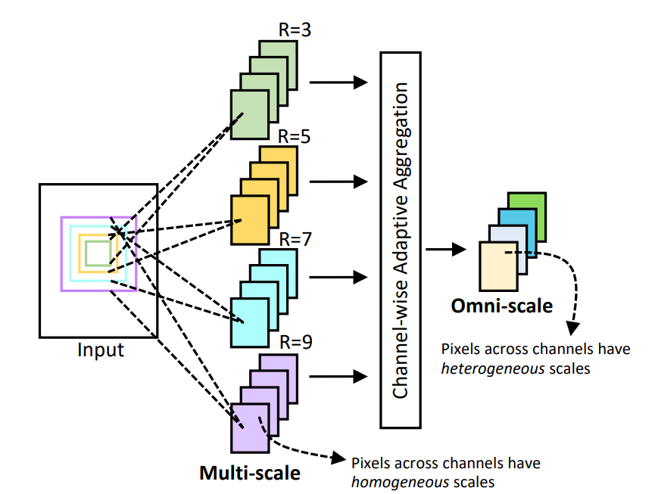
Figure 5) OSNet Architecture
This approach effectively captures omni-scale features, meaning the network can simultaneously learn global contextual cues (for large-scale variations) and fine-grained local details (for subtle appearance differences) from a single input image. OSNet's ability to seamlessly integrate and weigh features from multiple scales provided a highly efficient and exceptionally strong baseline, significantly improving the trade-off between model complexity and ReID accuracy.

CLIP-ReID: Exploiting Vision-Language Model for Image Re-Identification without Concrete Text Labels
CLIP-ReID (Zhong et al., 2022) [8] introduces a novel, text-agnostic approach to ReID by leveraging the powerful cross-modal understanding capabilities of the pre-trained Vision-Language Model (VLM), CLIP (Contrastive Language–Image Pre-training). The central challenge addressed is that standard ReID datasets only contain image pairs, lacking the rich, descriptive text (or concrete text labels) required to utilize CLIP effectively.
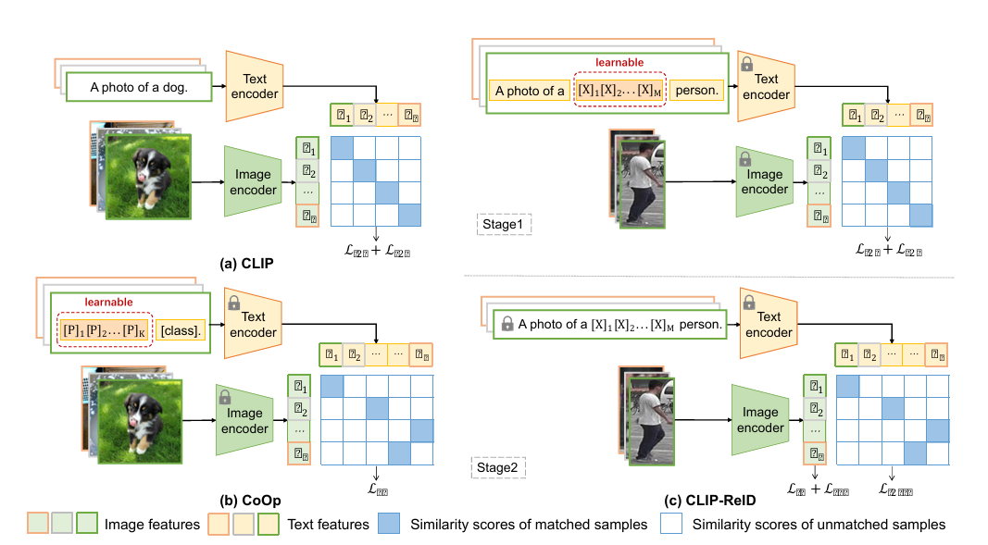
Figure 6) CLIP-ReID architecture
To overcome this, the method proposes two primary techniques: Prompt-based Feature Learning (PFL) and Context-Aware Discriminative Learning (CADL). PFL involves generating general or context-specific pseudo-text prompts (e.g., "a photo of a person") and utilizing CLIP's text encoder to produce prompt embeddings. The image embeddings are then aligned with these specialized prompt embeddings, effectively transferring the semantic and generalized knowledge of CLIP to the ReID task. This paradigm shifts ReID from a pure image-to-image matching task to a more robust semantic matching task, significantly boosting performance and generalization capability, particularly in zero-shot and domain-shift scenarios.

FSRA: Fine-grained Spatial-temporal Re-identification Attention
The Fine-grained Spatio-temporal Re-identification Attention (FSRA) method (Zhang et al., 2022) [9] addresses the core challenges inherent in Video-based Person ReID, where matching a person across different video sequences requires aggregating information across many frames. Standard approaches often struggle because simple temporal averaging loses discriminative details and treats noisy, occluded, or blurry frames as equally important as high-quality frames. FSRA tackles this by introducing a dual-attention mechanism: spatial attention to accurately locate subtle, identity-specific features (like logos or clothing details) within each individual frame, and temporal attention to dynamically weigh the contribution of each frame based on its informativeness and clarity. This combined approach ensures the network focuses on the best-quality, most characteristic visual cues, resulting in highly stable and discriminative per-frame feature extraction.
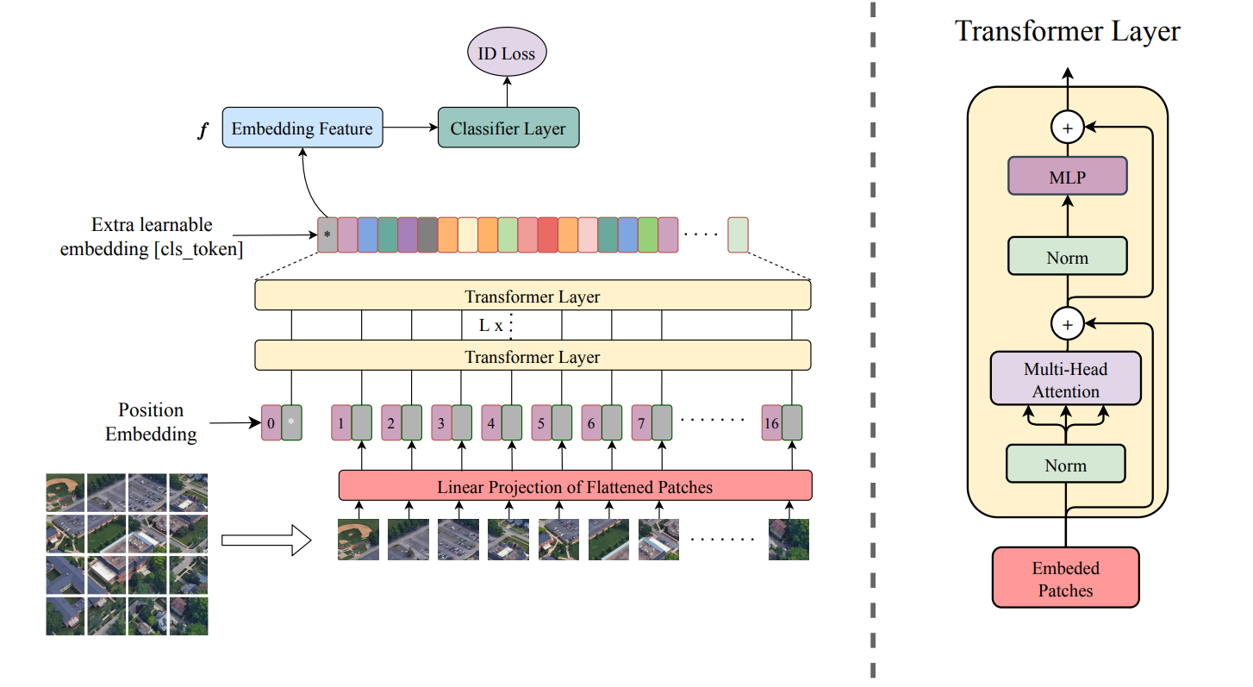
Figure 7) FSRA Architecture
By integrating these two modules, FSRA achieves a superior, consolidated feature representation for the entire video sequence. The network is explicitly trained to be robust to the common variations in surveillance video, simultaneously correcting for misalignment and background clutter spatially, while filtering out noise and poor quality temporally. This strategic fusion of fine-grained spatial and temporal cues significantly enhances the final retrieval accuracy, demonstrating the effectiveness of sophisticated attention modeling for achieving state-of-the-art performance in the challenging domain of video-based identity matching.

Conclusion
In summary, the evolution of ReID and geolocalization methodologies reflects a critical progression from general feature learning to increasingly specialized and robust techniques. Early work, exemplified by the Bag of Tricks, established strong baselines by optimizing training strategies, demonstrating the power of simple components and metric learning. Subsequent innovations introduced sophisticated mechanisms to handle real-world complexities: Deep Attention Aware methods enhance robustness against background noise and occlusion by directing the network's focus to discriminative human parts (Human ID). For structured objects, VehicleNet and Self-Supervised Geometric Feature Discovery push the limits of visual-only matching by leveraging rigid geometric features and view-invariant representations (Machine ID). Furthermore, OSNet solved the scale variation problem with omni-scale feature fusion, and FSRA extended attention to the temporal domain for reliable video-based retrieval. Most recently, CLIP-ReID marked a paradigm shift by successfully bridging the gap between traditional visual feature extraction and the generalized, semantic power of large pre-trained Vision-Language Models. Collectively, these methods define the current state-of-the-art by moving from simple global descriptors to fine-grained, robust, and often self-supervised feature engineering.

Evaluation
In Re-identification (ReID) and image retrieval tasks, two primary metrics are used to comprehensively assess a model's performance: Mean Average Precision (mAP), which evaluates the overall ranking quality, and the Cumulative Matching Characteristic (CMC) curve (often summarized by Rank-k accuracy), which measures the probability of a correct match appearing in the top results.

Mean Average Precision (mAP)
mAP is a single-number metric that quantifies the overall ranking quality across all queries (identities) in the test set. It is considered a more robust measure than Rank accuracy because it penalizes models that rank correct matches lower in the list, reflecting real-world scenario requirements where users or systems prioritize relevant results appearing at the very top.

Average Precision (AP): For a single query image (an identity), AP is calculated by finding the average of the precision values at every point in the ranked list where a correct match is retrieved. The formula essentially sums the precision at each rank k where a ground-truth match is found, divided by the total number of correct matches. This heavily rewards placing correct matches early.

Mean Average Precision (mAP): The mAP is the arithmetic mean of the Average Precision (AP) scores calculated for every query (identity) in the entire test set.
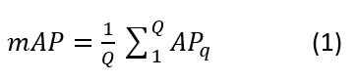
where Q is the total number of queries. A higher mAP (closer to 1.0 or 100%) indicates a superior model that accurately retrieves all correct matches and ranks them highly across all identities.

Cumulative Matching Characteristic (CMC) Curve and Rank-k
The CMC curve is a rank-based metric that evaluates the identification capability in a closed-set setting. It focuses on how quickly the model can return the correct match.

Rank-k Accuracy (Identification Rate): This is the probability that the correct match for a given query image is found within the top k retrieved results.
The most common specific metrics are:
Rank-1: The correct match is the first image retrieved. This is the strictest and most cited ReID metric.
Rank-5 or Rank-10: The correct match is found within the top 5 or 10 images, respectively.

CMC Curve: The full CMC curve is a plot of the Rank-k accuracy (Y-axis) against the rank k (X-axis). An ideal model achieves 100% accuracy (a value of 1.0) at Rank-1. The faster the curve rises to 100%, the better the model's perf ormance. The CMC curve is a measure of the model's robustness to rank error.

Open Challenges and Future Directions

Generalization and Domain Shift
A primary challenge in both Human ReID and Building Geolocalization is generalization and domain shift, meaning models trained extensively on one specific dataset (e.g., Market-1501 for humans or University-1652 for buildings) perform poorly when deployed on a new, unseen camera network or city. For Human ReID, this is exacerbated by changes in camera viewpoints, lighting conditions, and image resolution, which the current state-of-the-art often addresses with complex domain adaptation techniques that are computationally expensive. Similarly, in Building Geolocalization, models struggle with the extreme discrepancy between the ground-level query images and aerial gallery images (the cross-view gap), as they must match a building based on its facade details and context, which shift drastically with time, weather, and seasonal changes. Future research must prioritize robust Unsupervised Domain Adaptation (UDA) and Domain Generalization (DG) methods that allow models to learn invariant features that truly generalize across diverse deployment environments.

Privacy and Semantic Understanding
For Human ReID, the fundamental task conflicts directly with increasing privacy regulations, necessitating a shift toward privacy-preserving ReID. Future work must explore methods that minimize the use of personally identifiable information (PII) by focusing on soft biometrics, clothing attributes, or pose features, rather than facial details, potentially through encrypted domain learning or adversarial techniques. Simultaneously, both fields must move beyond simple feature embedding toward deeper semantic understanding. In Human ReID, this means developing models that can articulate why two images match (e.g., "same shirt, same backpack") rather than just giving a similarity score. For Building Geolocalization, this entails using the power of Vision-Language Models (VLMs) like CLIP to not just match pixels, but to locate landmarks based on high-level semantic descriptions (e.g., "the large, red-brick building next to the clock tower"), thus enabling more accurate and explainable retrieval.

Efficiency and Real-World Scale
The complexity of current state-of-the-art models, such as those employing dense attention mechanisms (like FSRA) or large foundation models (like CLIP-ReID), presents a major bottleneck for deployment at real-world scale and speed. The trade-off between retrieval accuracy and inference speed remains a critical issue for large-scale urban surveillance or real-time mobile geolocalization applications. The future direction must involve developing lightweight and efficient architectures capable of maintaining high accuracy while running on edge devices with limited computational resources. Furthermore, to handle exponentially growing gallery sizes (millions of people or buildings), research is needed in scalable indexing and retrieval techniques, specifically focusing on how to construct and search massive feature spaces rapidly without incurring the accuracy degradation associated with typical hashing or quantization methods.

Conclusion
This comprehensive review has charted the methodological advancements in instance recognition, spanning Human ReID, Machine ID, and Building Geolocalization, built upon a foundation of standardized datasets like Market-1501 and University-1652, and rigorously evaluated using metrics such as mAP and Rank-k accuracy. We observed a pivotal shift in deep learning methods, moving from generalized baselines established by the Bag of Tricks and omni-scale feature learning (like OSNet) to highly specialized, robust techniques. Key innovations include utilizing Attention Mechanisms (FSRA, Deep Attention Aware) to combat occlusion and temporal noise, leveraging Self-Supervised Geometric Features (VehicleNet) to stabilize matching for rigid objects, and embracing Vision-Language Models (CLIP-ReID) to introduce powerful semantic generalization. While performance has reached impressive levels across various benchmarks, future work must focus on the critical challenges of achieving true domain generalization, ensuring privacy preservation in human-centric applications, and developing computationally efficient architectures necessary for scalable, real-world deployment.

References
- Zheng, L., Shen, L., Tian, L., Wang, S., Wang, J. and Tian, Q., 2015. Scalable person re-identification: A benchmark. In Proceedings of the IEEE international conference on computer vision (pp. 1116-1124).
- Zheng, Z., Wei, Y. and Yang, Y., 2020, October. University-1652: A multi-view multi-source benchmark for drone-based geo-localization. In Proceedings of the 28th ACM international conference on Multimedia (pp. 1395-1403).
- Zhu, R., Yin, L., Yang, M., Wu, F., Yang, Y. and Hu, W., 2023. SUES-200: A multi-height multi-scene cross-view image benchmark across drone and satellite. IEEE Transactions on Circuits and Systems for Video Technology, 33(9), pp.4825-4839.
- Luo, H., Gu, Y., Liao, X., Lai, S. and Jiang, W., 2019. Bag of tricks and a strong baseline for deep person re-identification. In Proceedings of the IEEE/CVF conference on computer vision and pattern recognition workshops (pp. 0-0).
- Chen, Y., Wang, H., Sun, X., Fan, B., Tang, C. and Zeng, H., 2022. Deep attention aware feature learning for person re-identification. Pattern Recognition, 126, p.108567.I. S. Jacobs and C. P. Bean, “Fine particles, thin films and exchange anisotropy,” in Magnetism, vol. III, G. T. Rado and H. Suhl, Eds. New York: Academic, 1963, pp. 271–350.
- Zheng, Z., Ruan, T., Wei, Y., Yang, Y. and Mei, T., 2020. VehicleNet: Learning robust visual representation for vehicle re-identification. IEEE Transactions on Multimedia, 23, pp.2683-2693.
- Li, M., Huang, X. and Zhang, Z., 2021. Self-supervised geometric features discovery via interpretable attention for vehicle re-identification and beyond. In Proceedings of the IEEE/CVF international conference on computer vision (pp. 194-204).
- Zhou, K., Yang, Y., Cavallaro, A. and Xiang, T., 2019. Omni-scale feature learning for person re-identification. In Proceedings of the IEEE/CVF international conference on computer vision (pp. 3702-3712).
- Li, S., Sun, L. and Li, Q., 2023, June. Clip-reid: exploiting vision-language model for image re-identification without concrete text labels. In Proceedings of the AAAI conference on artificial intelligence (Vol. 37, No. 1, pp. 1405-1413).
- Chen, G., Lu, J., Yang, M. and Zhou, J., 2019. Spatial-temporal attention-aware learning for video-based person re-identification. IEEE Transactions on Image Processing, 28(9), pp.4192-4205.

